Test Case: tc005_SPX_Dev5_Crear_Requisicion_Spot_Con_FAD_Tipo_Cobro_Project
Step 1 - Enter username and password and click to button Enter: Credentials Entered
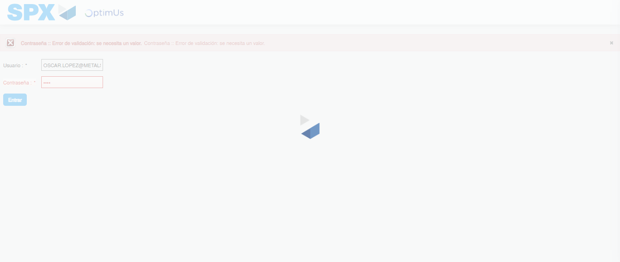Image file-name: QC_Testing-tc005_SPX_Dev5_Crear_Requisicion_Spot_Con_FAD_Tipo_Cobro_Project-1784574021252

Step 2 - Select to UEN and Access to Spot Buy Requisitions : UEN Correctly selected and Correct access
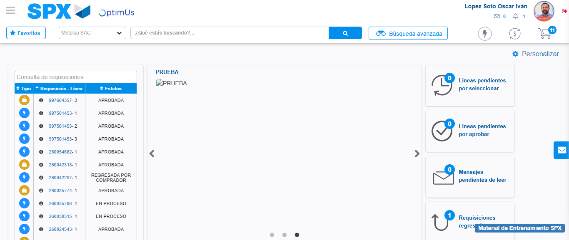Image file-name: QC_Testing-tc005_SPX_Dev5_Crear_Requisicion_Spot_Con_FAD_Tipo_Cobro_Project-1784574094963

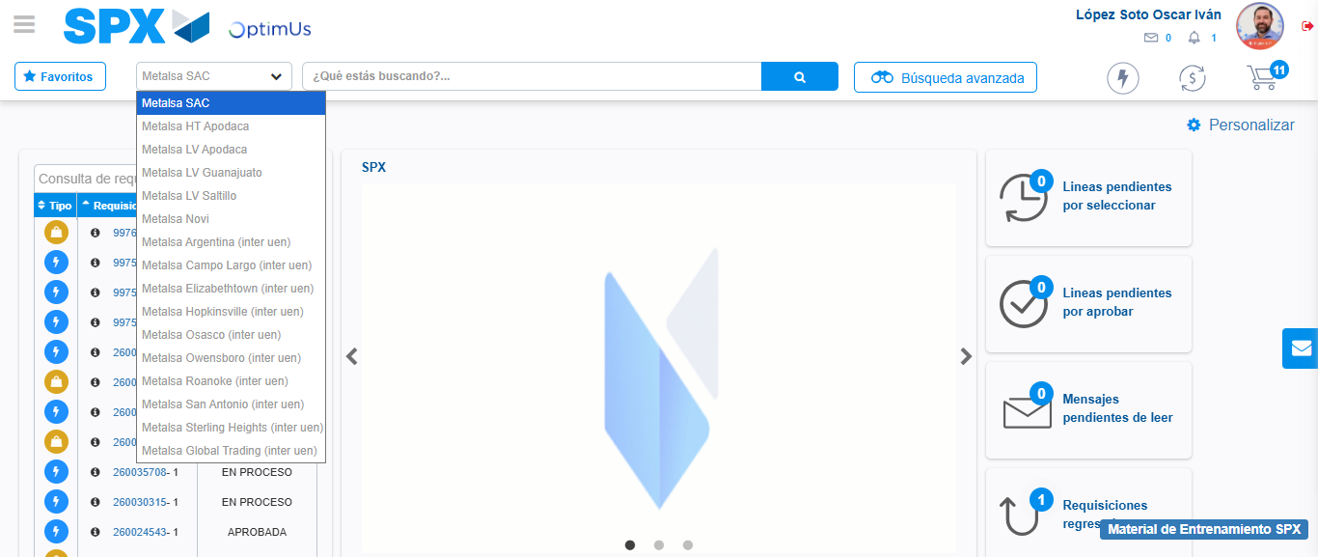Image file-name: QC_Testing-tc005_SPX_Dev5_Crear_Requisicion_Spot_Con_FAD_Tipo_Cobro_Project-1784574097653

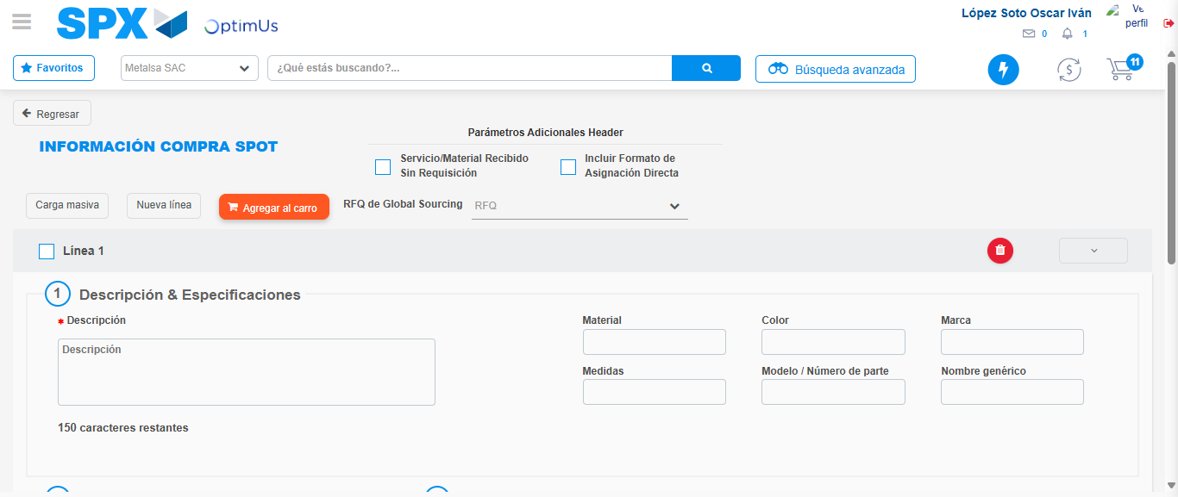Image file-name: QC_Testing-tc005_SPX_Dev5_Crear_Requisicion_Spot_Con_FAD_Tipo_Cobro_Project-1784574107587

Step 3 - Add FAD to Requisition: FAD Successfully Added
Image file-name: QC_Testing-tc005_SPX_Dev5_Crear_Requisicion_Spot_Con_FAD_Tipo_Cobro_Project-1784574107840

Image file-name: QC_Testing-tc005_SPX_Dev5_Crear_Requisicion_Spot_Con_FAD_Tipo_Cobro_Project-1784574108075

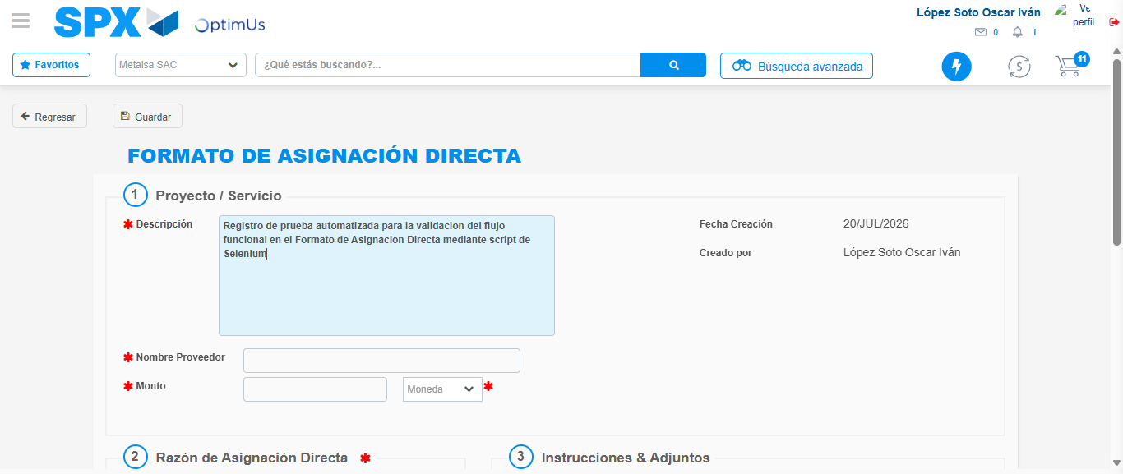Image file-name: QC_Testing-tc005_SPX_Dev5_Crear_Requisicion_Spot_Con_FAD_Tipo_Cobro_Project-1784574111142

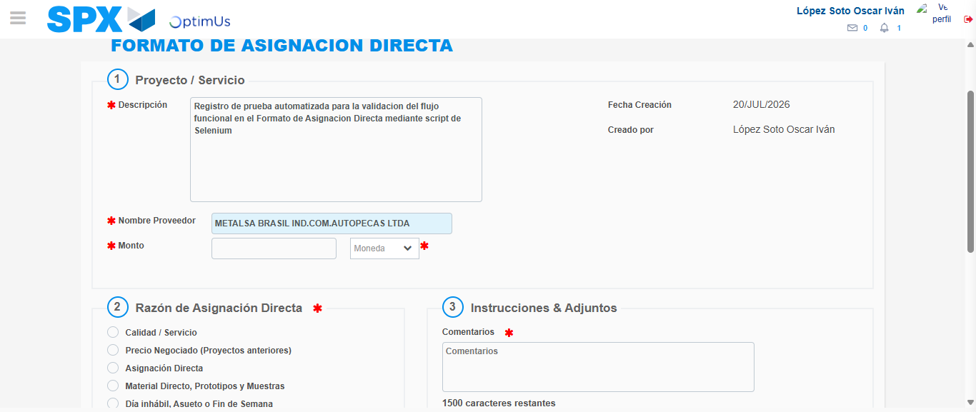Image file-name: QC_Testing-tc005_SPX_Dev5_Crear_Requisicion_Spot_Con_FAD_Tipo_Cobro_Project-1784574118477

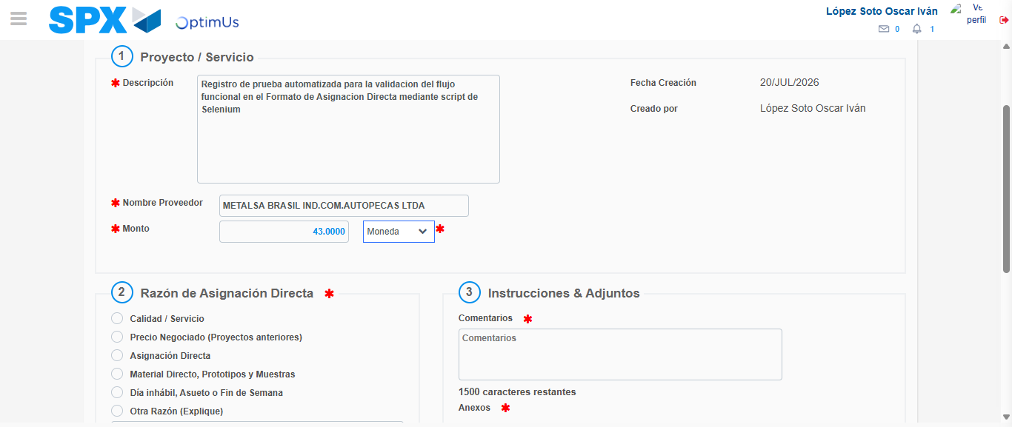Image file-name: QC_Testing-tc005_SPX_Dev5_Crear_Requisicion_Spot_Con_FAD_Tipo_Cobro_Project-1784574119157

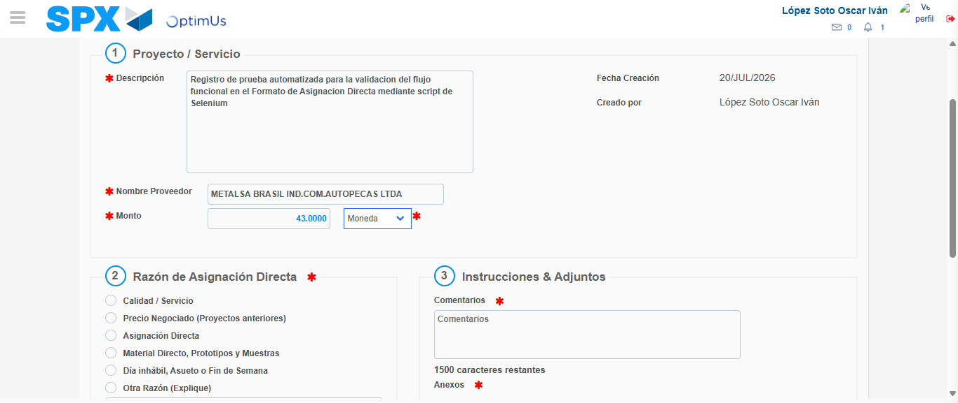Image file-name: QC_Testing-tc005_SPX_Dev5_Crear_Requisicion_Spot_Con_FAD_Tipo_Cobro_Project-1784574119387

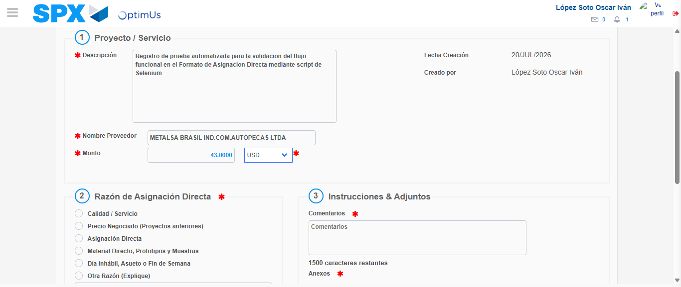Image file-name: QC_Testing-tc005_SPX_Dev5_Crear_Requisicion_Spot_Con_FAD_Tipo_Cobro_Project-1784574119907

Image file-name: QC_Testing-tc005_SPX_Dev5_Crear_Requisicion_Spot_Con_FAD_Tipo_Cobro_Project-1784574120117

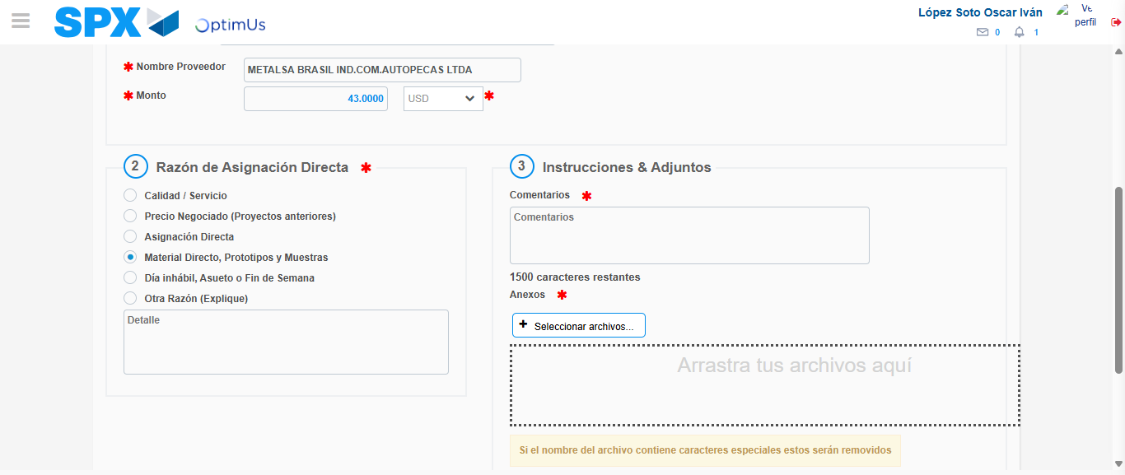Image file-name: QC_Testing-tc005_SPX_Dev5_Crear_Requisicion_Spot_Con_FAD_Tipo_Cobro_Project-1784574121118

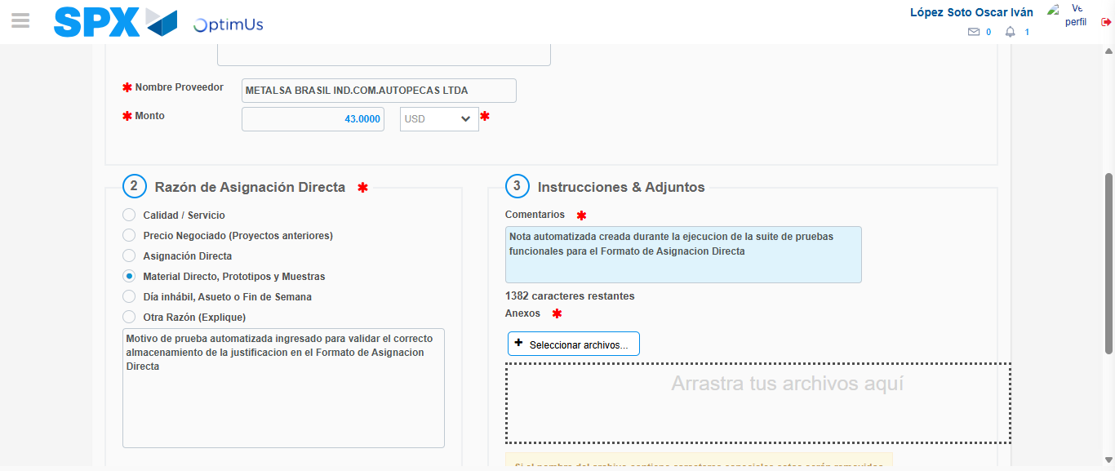Image file-name: QC_Testing-tc005_SPX_Dev5_Crear_Requisicion_Spot_Con_FAD_Tipo_Cobro_Project-1784574132494

Image file-name: QC_Testing-tc005_SPX_Dev5_Crear_Requisicion_Spot_Con_FAD_Tipo_Cobro_Project-1784574133330

Step 4 - Data Capture Spot Buy Requisition: Data captured correctly
Image file-name: QC_Testing-tc005_SPX_Dev5_Crear_Requisicion_Spot_Con_FAD_Tipo_Cobro_Project-1784574107840

Image file-name: QC_Testing-tc005_SPX_Dev5_Crear_Requisicion_Spot_Con_FAD_Tipo_Cobro_Project-1784574108075

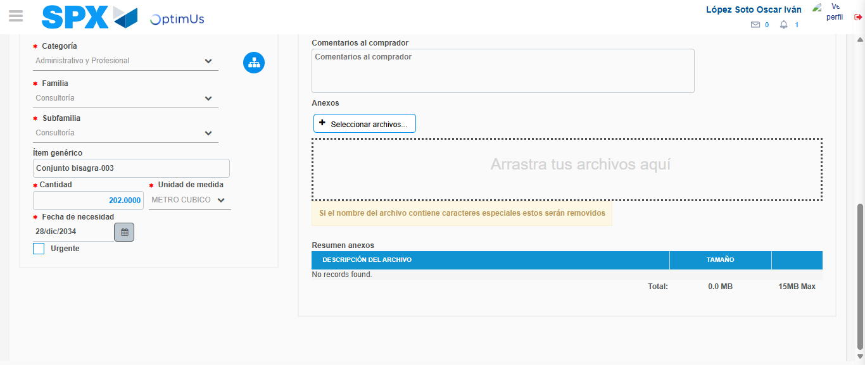Image file-name: QC_Testing-tc005_SPX_Dev5_Crear_Requisicion_Spot_Con_FAD_Tipo_Cobro_Project-1784574146637

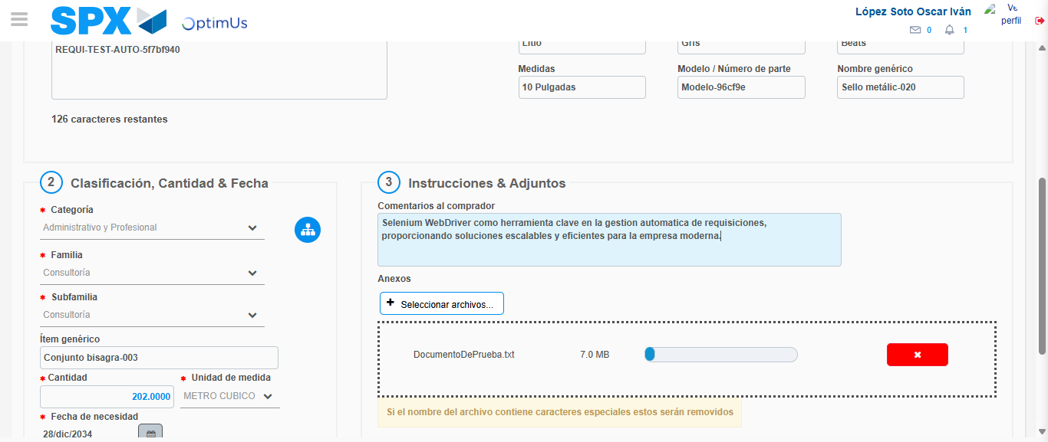Image file-name: QC_Testing-tc005_SPX_Dev5_Crear_Requisicion_Spot_Con_FAD_Tipo_Cobro_Project-1784574147679

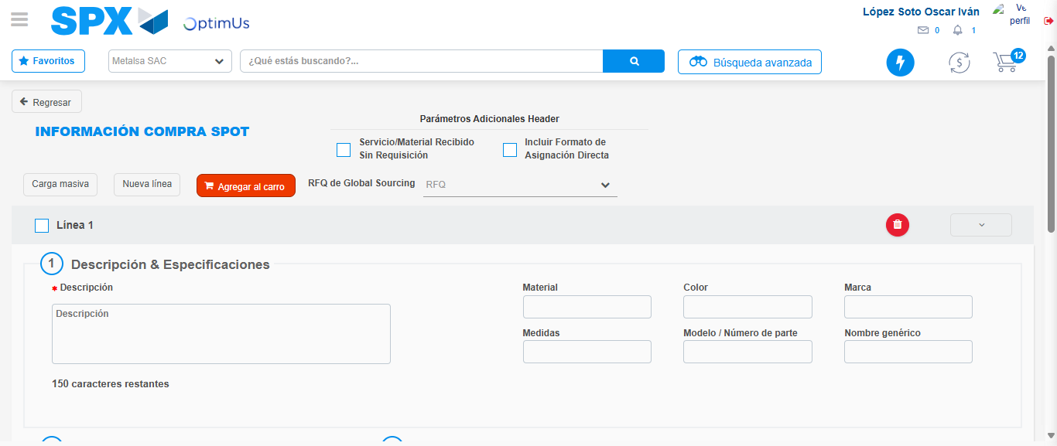Image file-name: QC_Testing-tc005_SPX_Dev5_Crear_Requisicion_Spot_Con_FAD_Tipo_Cobro_Project-1784574155355

Step 8 - Return to Main Page SPX : Return to Main Page SPX
Image file-name: QC_Testing-tc005_SPX_Dev5_Crear_Requisicion_Spot_Con_FAD_Tipo_Cobro_Project-1784574094963

Image file-name: QC_Testing-tc005_SPX_Dev5_Crear_Requisicion_Spot_Con_FAD_Tipo_Cobro_Project-1784574097653

Image file-name: QC_Testing-tc005_SPX_Dev5_Crear_Requisicion_Spot_Con_FAD_Tipo_Cobro_Project-1784574107587

Image file-name: QC_Testing-tc005_SPX_Dev5_Crear_Requisicion_Spot_Con_FAD_Tipo_Cobro_Project-1784574157593

Image file-name: QC_Testing-tc005_SPX_Dev5_Crear_Requisicion_Spot_Con_FAD_Tipo_Cobro_Project-1784574157781

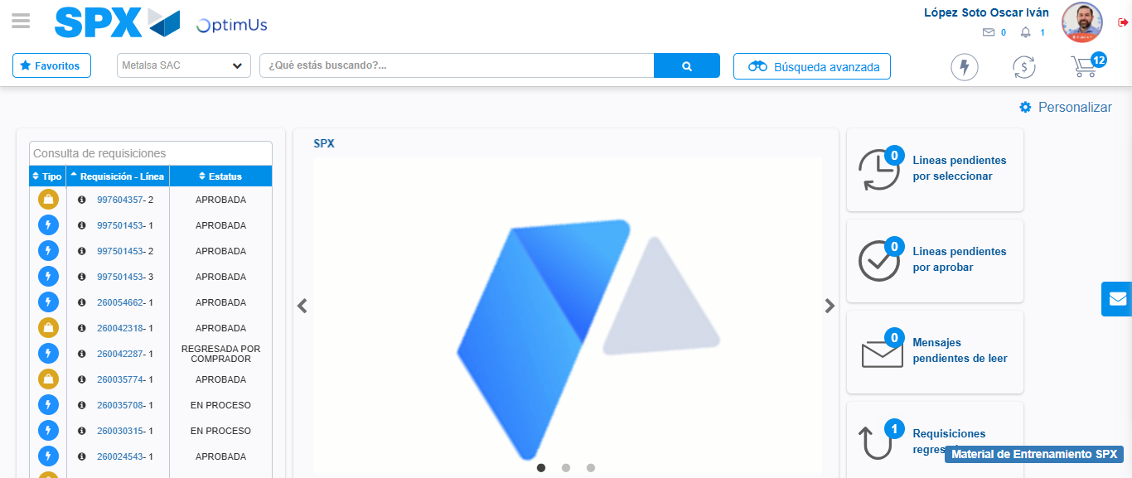Image file-name: QC_Testing-tc005_SPX_Dev5_Crear_Requisicion_Spot_Con_FAD_Tipo_Cobro_Project-1784574179411

Step 9 - Log Out : Log Out SPX
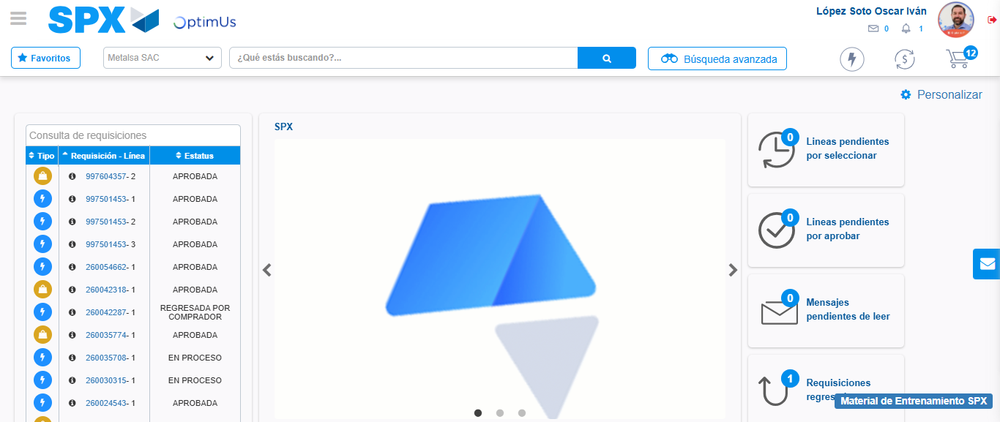Image file-name: QC_Testing-tc005_SPX_Dev5_Crear_Requisicion_Spot_Con_FAD_Tipo_Cobro_Project-1784574179788

